CSCI/CMPE 4301 DIP Guide
Open book and notes
Jupytor notebook
Exam-03 Name:
The third exam will have 3 questions to be implemented in a notebook.
Make sure to know how to start and save a notebook. Loss of file or inability to read it is your responsibility.

Show all work for full credit.
- Given two histograms of color, calculate the minimum intersection metric given by the following formula. Use NumPy to create two test histograms of size 10, populate them with random data, then calculate the distance.

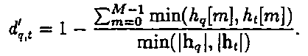

- You will be given an image and you goal is to create and show the HOG features for those features. You can use “from skimage import feature” to calculate the hog feature.
  - Your notebook will read the image, show the original image, calculate the hog, then show the hog image.

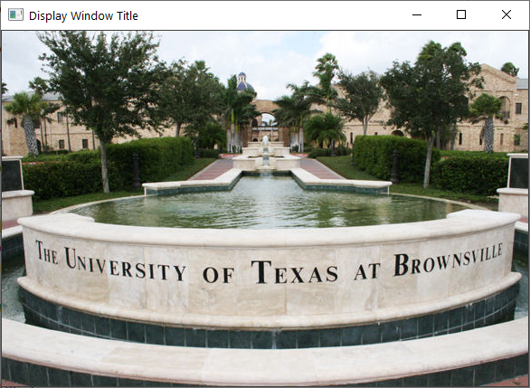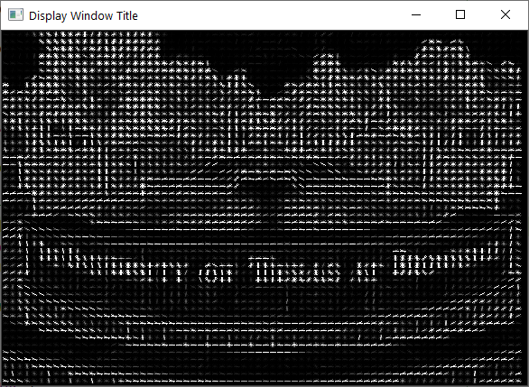

- Given an image (or a video) with possible blood spots/areas in it. Use the HSV color space to highlight the area with blood (using a bit-wise mask), if present.
  - Check the color as feature slides, and particularly the python code that detects the blue caps. You should understand the code there, then adjust it to detect the blood.

